# Media Analysis - Is the Arab world ready for the uncertain age of AI-powered web tools_Updated 09 March 2023

## Short Summary

Certainly Here s a concise summary of the key points and themes from your provided text Key Points 1.

## Summary

To transform the provided text into an outline format with subheadings, bullet points, and a separate section for data, we can organize the information as follows:  
  
---  
  
## Overview of Artificial Intelligence (AI) Developments  
  
### Introduction to AI's Impact on Various Sectors  
  
- **Content Creation and Assistance**  
 - ChatGPT's role in generating text-based content across various applications.  
 - Applications include social media posts, blogs, business plans, reports, emails, presentations, legal documents, medical summaries, and customer service responses.  
  
### Educational Implications of AI  
  
- Challenges posed by chatbots to educational institutions.  
 - Adoption of paper-based tests to prevent AI cheating during exams.  
 - Sanctions for students using ChatGPT at prestigious institutions like Sciences Po school in Paris.  
   
- Case Study: Minnesota University Law School  
 - ChatGPT successfully passed law school exams, earning a C grade.  
  
### Technological Limitations and Capabilities  
  
- **ChatGPT's Abilities**  
 - Generates text based on patterns seen during training.  
 - Cannot replicate human creativity, emotion, or perspective.  
  
- Alternative AI Models Emerging alongside Large-Language Models (LLMs)  
 - Reinforcement learning  
 - Generative adversarial networks  
 - Symbolic AI  
  
### Economic Impact and Investment Potential of AI  
  
- **Global Market Value and Growth**  
 - Estimated global market value in 2022: $119.78 billion.  
 - Expected contribution to the global economy by 2030: $15.7 trillion.  
 - Projected growth over the next eight years: 13 times.  
 - Number of people working in AI by 2024: 97 million.  
  
- Middle East's Share  
 - Projected to accrue 2% of global benefits from AI, equivalent to $320 billion.  
  
### Trust and Future Outlook  
  
- **Balancing Optimism and Pessimism**  
 - Dr. Scott Nowson emphasizes the importance of trust in AI's safe expansion.  
 - Human intelligence remains crucial for leveraging AI effectively.  
 - Long-term view: AI will not replace human capabilities anytime soon.  
  
---  
  
This outline captures the key points, data, and structure from the original text while organizing them into a clear format with subheadings and bullet points.

## Question 1

The text provided discusses how various media outlets and experts frame public discussions around ChatGPT, an AI language model developed by OpenAI. Here are some key metaphors and frames identified in the discussion:  
  
1. **"Age of Anxiety"**: This metaphor suggests a period characterized by uncertainty and concern about the implications of AI technologies like ChatGPT. It captures the mixed feelings—both excitement and apprehension—that surround AI advancements.  
  
2. **"Trust is Key"**: The text emphasizes trust as central to safely integrating AI into various sectors, indicating that public confidence in AI's reliability and ethical use is crucial for its widespread adoption.  
  
3. **"Not a Replacement but an Assistant"**: ChatGPT itself uses this framing to position itself not as a replacement for human capabilities but rather as a tool that can assist with specific tasks while acknowledging the irreplaceable value of human creativity, emotion, and perspective.  
  
4. **"AI Cheats" vs. "Human Ingenuity"**: The discussion around AI's ability to pass exams or generate content highlights concerns about authenticity and originality versus human intellectual contributions. This frames ChatGPT as a tool that can mimic certain patterns but not replicate the depth of human thought and creativity.  
  
5. **"Learning from Patterns"**: Describing AI as machines for matching patterns rather than truly understanding concepts emphasizes the limitations of current technology, suggesting it lacks genuine comprehension or insight.  
  
6. **"Many Generations Away"**: This metaphor reflects a long-term view of technological evolution, framing AI's progression towards surpassing human intelligence as something that will take decades, not years.  
  
These metaphors collectively frame ChatGPT and similar technologies within narratives of cautious optimism, emphasizing both their potential benefits and limitations while highlighting the importance of ethical considerations and trust in technology.

## Question 2

The passage provides a comprehensive overview of various perspectives and aspects related to artificial intelligence (AI), specifically focusing on large-language models like ChatGPT. Here's a breakdown:  
  
### Widely Covered Aspects  
  
1. **Economic Impact**:   
 - The global market value of AI, projected contributions to the economy by 2030, and regional economic benefits (e.g., Middle East accruing 2% of global benefits).  
  
2. **Educational Challenges**:  
 - Concerns over AI cheating in exams have led institutions to modify testing methods.  
  
3. **Technological Capabilities and Limitations**:  
 - ChatGPT's abilities and limitations, such as its reliance on pattern recognition and lack of creativity or emotional depth.  
 - Comparison with other AI models like reinforcement learning and generative adversarial networks (GANs).  
  
4. **Ethical and Practical Considerations**:  
 - The need for fact-checking despite the utility of AI tools.  
 - Trust issues surrounding AI use and its safe expansion.  
  
5. **Applications Across Sectors**:  
 - Diverse applications ranging from content creation to medical diagnosis, highlighting both potential and investment interest.  
  
6. **Human-AI Collaboration**:  
 - Emphasis on human intelligence being crucial for effective AI implementation, with AI seen as a tool rather than a replacement.  
  
### Ignored or Underrepresented Aspects  
  
1. **Long-term Societal Impact**:  
 - The passage touches briefly on potential societal changes but doesn't delve deeply into long-term impacts beyond the workforce.  
  
2. **Regulatory and Policy Frameworks**:  
 - There is little discussion about how governments are planning to regulate AI, apart from institutional bans during exams.  
  
3. **Data Privacy Concerns**:  
 - The privacy implications of data used for training large-language models like ChatGPT aren't discussed in detail.  
  
4. **Diverse Cultural Perspectives on AI**:  
 - There is a lack of insight into how different cultures perceive and are adopting AI technologies.  
  
5. **Detailed Case Studies or Success Stories**:  
 - Specific examples or case studies illustrating successful integration of AI in various industries are missing.  
  
6. **Environmental Impact**:  
 - The environmental costs associated with training large-scale AI models aren't addressed.  
  
This analysis reflects a balanced discussion on AI's current landscape, though it could benefit from more exploration into regulatory and cultural dimensions.

## Question 3

The article discusses the role of the Arab world, specifically mentioning countries like Saudi Arabia and the UAE, in leveraging artificial intelligence (AI). Here's a summary:  
  
1. **Investment and Development**: The Arab world is investing significantly in AI technology to enhance economic development and diversification. For example, Saudi Arabia has launched an ambitious plan called NEOM, which aims to incorporate AI into its infrastructure.  
  
2. **Economic Contribution**: It is projected that the Middle East will accrue about 2% of the global benefits from AI by the end of the decade, amounting to $320 billion.  
  
3. **Innovation Hubs and Government Initiatives**: The UAE has established hubs like the Dubai Future Foundation to foster innovation in AI technologies, emphasizing research and development in this field.  
  
4. **Educational Influence**: There are initiatives within the region's education systems that recognize AI's role but also address its challenges, such as cheating during exams. For instance, Ahmed Belhoul Al-Falasi, the UAE Minister of Education, acknowledges both potential benefits and concerns regarding AI in educational contexts.  
  
Overall, the Arab world is actively engaging with AI technologies to boost economic growth, drive innovation, and tackle regional challenges, while also being mindful of ethical considerations.

## Question 4

The article discusses both the potential and challenges of artificial intelligence (AI), particularly focusing on ChatGPT's capabilities and limitations. While AI, like ChatGPT, offers innovative applications across various fields—from content creation to medical diagnosis—it also raises concerns about trust, accuracy, and ethical use. Human oversight remains crucial for safe AI expansion, ensuring it complements rather than replaces human skills. Despite significant investment potential in AI, a balance between optimism and caution is advocated, emphasizing the continued importance of human intelligence and skepticism.

## Sentiment

The sentiment is 1.0

## Entities

Jenna Burrell, Bing, UAE, DeenSquare, AFP Founded, Generative Pre-Trained Transformer, LinkedIn, Dan Milmo, Alexa, PwC Middle Easts, Google, Ahmed Belhoul Al-Falasi, Reid Ho, OpenAI, Dubais Museum of the Future, AI, Edge, GPT, Intelligence, YouTube, James Webb, Arab News, Microsoft, LEAP, the World Economic Forum, Elon Musk, Nowson, AFP However, Sam Altman, the Sciences Po school, Noaman Sayed, Bard, Data Society, Scott Nowson, Omar Sultan Al-Olama, Peter Thiel, Googles, Minnesota University Law School, Guardian, ChatGPT, Burrell, New York Citys, Alex Hern, National Strategy for Data

## Highlights

#7cc867#fb5b89#c885da#f9cd59

## Wordcloud for #7cc867 Highlights

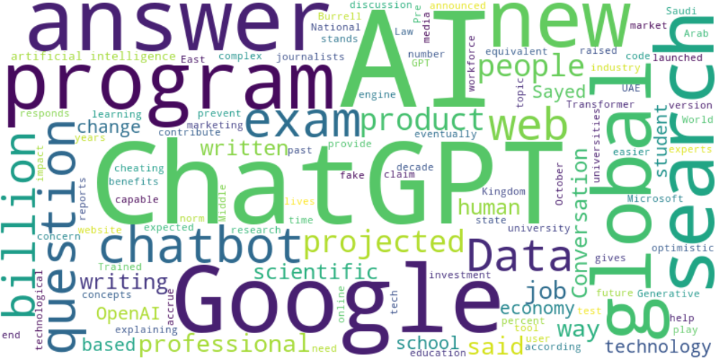

Top 10 words:

- AI: 16

- ChatGPT: 11

- Google: 7

- global: 5

- search: 5

- questions: 4

- web: 4

- billion: 4

- people: 4

- said: 4

## Wordcloud for #fb5b89 Highlights

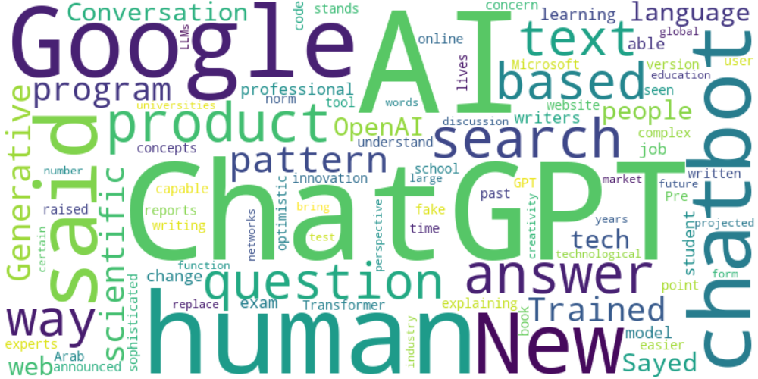

Top 10 words:

- AI: 12

- ChatGPT: 11

- Google: 7

- human: 5

- said: 5

- search: 4

- based: 4

- text: 4

- scientific: 3

- language: 3

## Wordcloud for #c885da Highlights

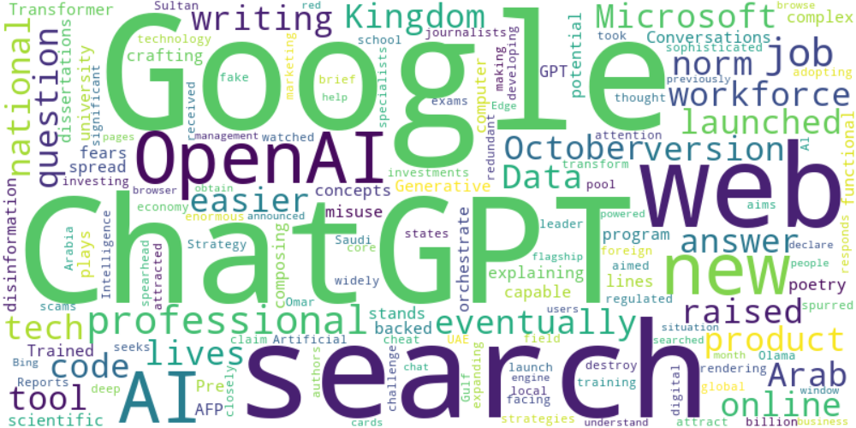

Top 10 words:

- Google: 6

- ChatGPT: 5

- search: 4

- web: 3

- OpenAI: 3

- AI: 3

- writing: 2

- code: 2

- Microsoft: 2

- raised: 2

## Wordcloud for #f9cd59 Highlights

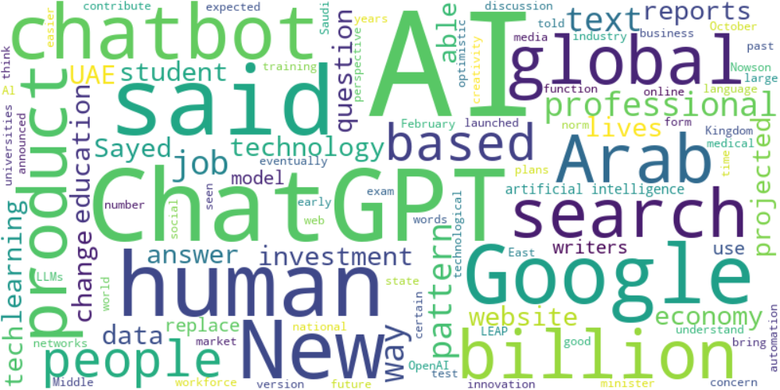

Top 10 words:

- AI: 24

- ChatGPT: 9

- said: 8

- Google: 6

- human: 5

- Arab: 4

- global: 4

- search: 4

- based: 4

- text: 4